1. Create a table comparing Agile and Waterfall models across 5 factors relevant to software testing, such as requirements, feedback cycle, tester involvement, documentation, and flexibility.

Answer:
The table below compares how testing works in the Waterfall and Agile models:
Factor | Waterfall Model | Agile Model
Requirements | Fully defined and frozen at the start. Changes are difficult and need a formal change request. | Written as user stories and refined in every sprint. Changes are welcome.
Feedback Cycle | Feedback comes late, only after the testing phase at the end of the project. | Feedback comes every sprint (1 to 4 weeks) from testing, demos and the Product Owner.
Tester Involvement | Testers join after development is finished and work in a separate testing phase. | Testers are part of the team from backlog grooming to release and test in every sprint.
Documentation | Heavy and formal: detailed test plans, test cases and reports are prepared before testing. | Light: user stories with acceptance criteria, just-enough test cases and checklists.
Flexibility | Low. A scope change means reworking the plans, test cases and schedule. | High. The test plan and priorities can change in every sprint.
2. Pick any app you use daily (like Instagram, Zomato, or Paytm) and describe how the testing process would look different if the team used Agile instead of Waterfall. Mention at least 3 specific testing activities or practices that would change.

Answer:
App chosen: Instagram, with a new feature called 'Add Music to Post'. With Waterfall, the team would collect all the requirements first, build the whole release, and then test everything in one long phase before a single big release. With Agile, the same feature is built and tested in short sprints. These testing activities would change:
Testing Activity | In Waterfall | In Agile
Test planning | One big master test plan is written at the start for the whole release. | A short test plan is made for each sprint and updated as priorities change.
Test case design | All test cases are written after the requirements are signed off, before any code exists. | Test cases are written for each user story from its acceptance criteria, while the feature is being built.
Test execution | Testing starts only after all features are developed, in one long phase. | Each story is tested as soon as it is ready, in the same sprint, with automated tests on every build.
Regression testing | Done once, near the end, just before the release. | Done every sprint with an automated suite, so the feed, upload and stories are rechecked often.
Bug reporting and fixing | Bugs are found late and reported in bulk, and fixes take a long time. | Bugs are reported at once, discussed in the daily standup and fixed in the same sprint.
3. Draw a simple workflow diagram showing the main roles (such as Scrum Master, Product Owner, Development Team, Tester) and ceremonies (like Sprint Planning, Daily Standup, Sprint Review) in a SCRUM process.

Answer:
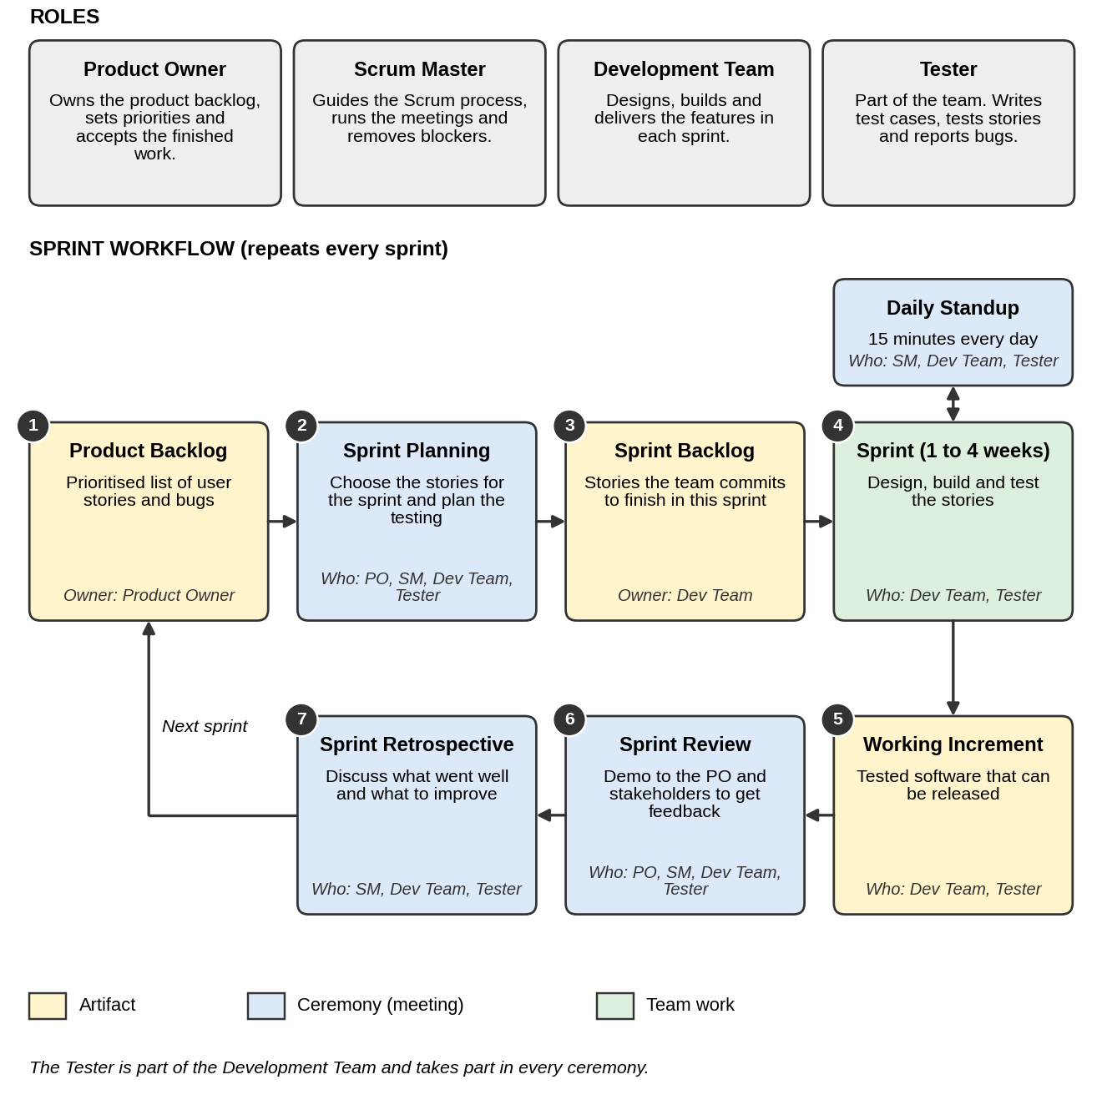
4. For a food delivery app (like Swiggy), map out which testing activities should happen during each phase of a typical Agile sprint (e.g., backlog grooming, sprint planning, development, review).

Answer:
Sample user story: "As a Swiggy customer, I want to apply a coupon at checkout so that I get a discount on my order." The table shows what the tester does in each phase of the sprint.
Sprint Phase | Testing Activities
Backlog Grooming | - Help write and refine user stories with clear acceptance criteria (for example, an expired coupon must be rejected).  - Review the stories for unclear or missing requirements and ask questions.
Sprint Planning | - Pick the stories and estimate the testing effort for each.  - Plan test data and environments (test coupons, test restaurants, UPI sandbox).  - Agree that "tested, with no major open bugs" is part of the Definition of Done.
Development (start of sprint) | - Design test cases from the acceptance criteria (valid, invalid and boundary cases).  - Prepare test data and write automation scripts.  - Review unit tests with the developers.
Testing (during the sprint) | - Execute test cases on each story as soon as it is ready, including cart and payment integration checks.  - Report bugs at once with steps and screenshots, and retest the fixes.  - Run the regression suite (checkout, payment, order tracking) on every build.
Daily Standup (every day) | - Share test progress and blockers (for example, a test environment is down or a bug blocks a story).
Sprint Review | - Demo the tested stories and share the test results with the Product Owner.  - Accept or reject stories using the acceptance criteria. Add feedback and new bugs to the backlog.
Sprint Retrospective | - Discuss escaped bugs, automation gaps and delays, and agree one testing improvement for the next sprint.

